 | SR UNIVERSITY  Campus Warangal
 | Program: II - B. Tech (CS& AI) Batch:
 | Name: P. AGASTYA Reg. No:2503A54019
 | Department: Computer Science and AI Semester: 3
 | AI Assisted Coding-Assignment Date: 18-09-2026

Q1. Class with Conditional Logic – Employee Salary
Scenario:
An AI coding assistant is used to develop a simple employee salary management program.
Task:
Using AI-assisted code completion, write a Python class Employee that:
- Stores employee name and basic salary.
- Has a method calculate_bonus() that:
  - Returns 10% of salary if salary is ₹50,000 or above.
  - Returns 5% of salary otherwise.
- Has a method display_details() to display the employee name, salary, and bonus.
- Create at least two employee objects and test the class.
.
Prompt:
Create a Python program using an Employee class with name and basic_salary. Calculate a 10% bonus if salary ≥ ₹50,000, otherwise 5%. Calculate and display the total salary. Create two employee objects and test both conditions
Code & output:

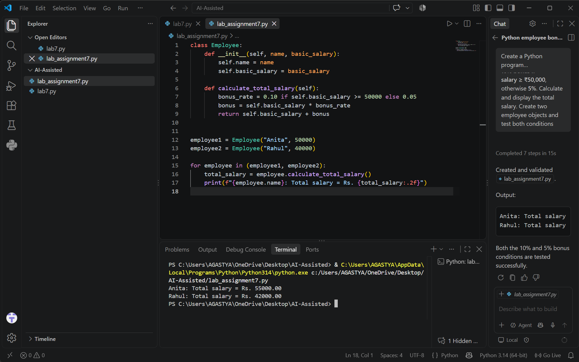

Observation:
Learned to create classes and objects, use methods, and apply conditional logic to calculate employee bonuses.
Q2. Loop and Conditional Logic – Student Marks
Scenario:
A teacher wants to analyze the marks of students using an AI coding assistant.
Task:
Using AI-assisted code completion, write a Python program that:
- Accepts a list of student marks.
- Uses a loop to process each mark.
- Displays:
  - "Distinction" for marks ≥ 75
  - "Pass" for marks ≥ 40 and < 75
  - "Fail" for marks < 40
- Ignores invalid marks outside 0–100.
- Calculates and displays the number of students in each category.
- Test the program with a suitable list of marks.
Prompt:
Create a Python program using a loop to process a list of student marks.
Display Distinction (≥75), Pass (40–74), or Fail (<40), and ignore invalid marks.
Count and display the number of students in each category.
Code & Output :
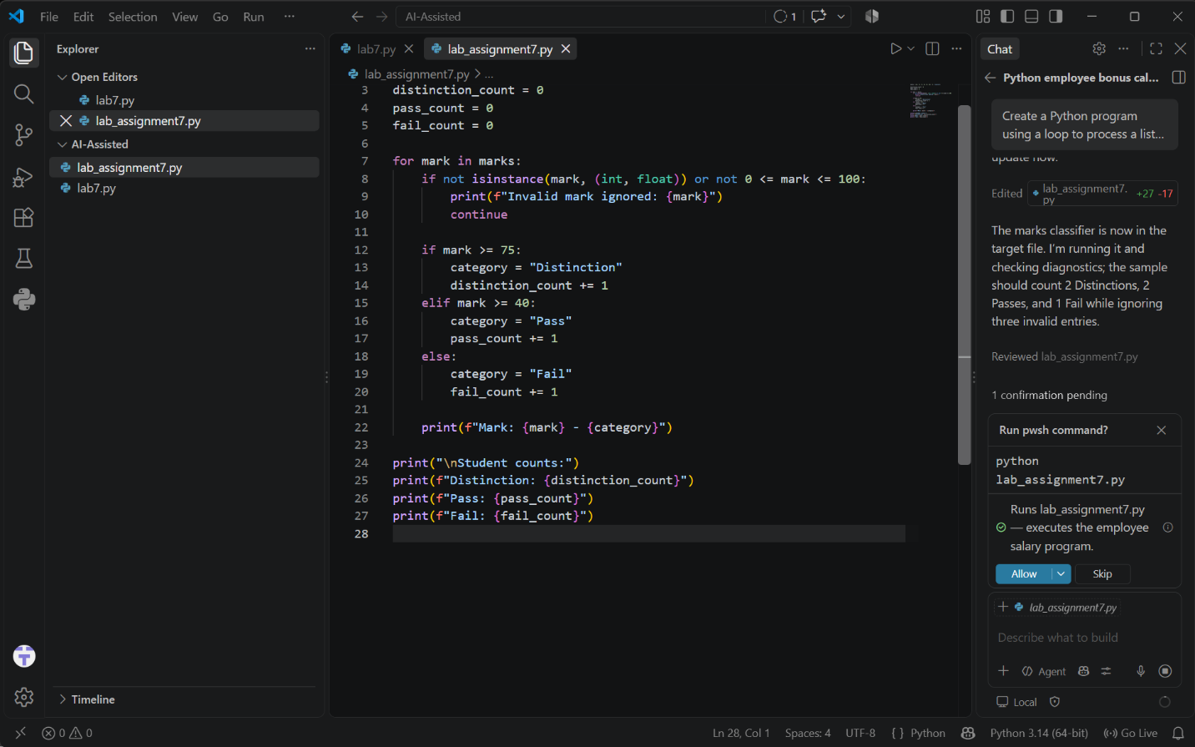
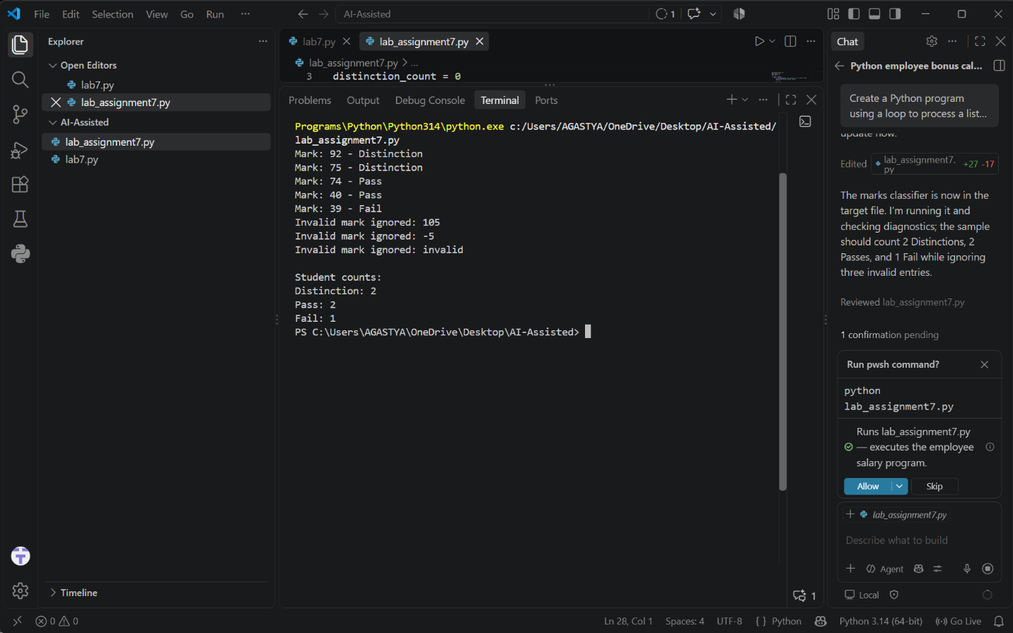
Observation:
Learned how to use loops and conditional statements to classify and count student marks.
Q3. Class + Loop – Product Inventory
Scenario:
A small store wants to maintain product inventory using a Python program generated with AI assistance.
Task:
Using AI-assisted code completion, create a class Product that:
- Stores product name, price, and quantity.
- Has a method total_value() that calculates price × quantity.
- Create a list of multiple Product objects.
- Use a loop to calculate the total inventory value.
- Display the products whose quantity is less than 5 as "Low Stock".
- Test the program with at least three products.
Prompt:
Create a Python program using a Product class with product name, price, and quantity. Calculate total value using price × quantity and use a loop to process multiple products. Display products with quantity less than 5 as "Low Stock" and calculate total inventory value.
Code & Output :
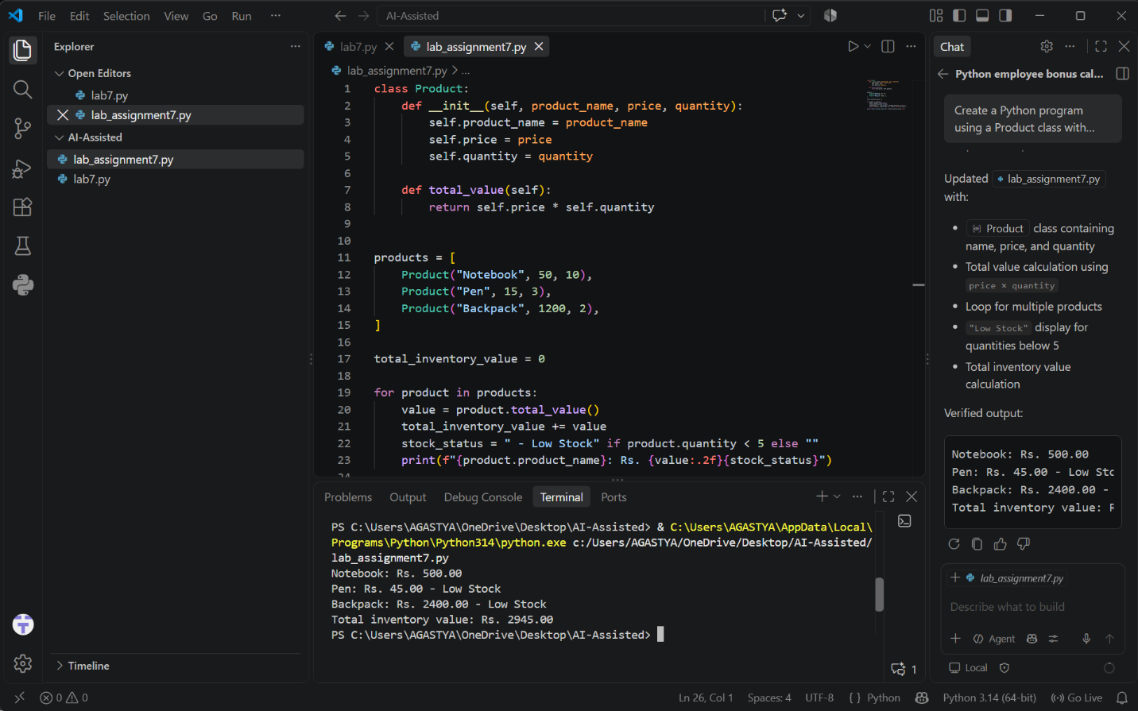
Observation:
Learned to use classes and loops to manage product details and calculate total inventory value.
Q4. Class + Loop + Nested Conditions – Electricity Bill
- Scenario:
An electricity board wants to calculate bills based on units consumed.
- Task:
Using AI-assisted code completion, create a Python class ElectricityBill that:
- Stores the consumer name and units consumed.
- Calculates the bill using:
- First 100 units → ₹2/unit
- 101–200 units → ₹3/unit
- Above 200 units → ₹5/unit
- Uses appropriate loops and conditional statements where required.
- Displays the consumer name, units, and total bill.
- Create at least three objects and display their bills.
- Test the program with different unit values, including an edge value such as 100 or 200.
Prompt:
Create a Python program using an Electricity Bill class with consumer name and units consumed. Calculate the bill using ₹2/unit for the first 100, ₹3/unit for 101–200, and ₹5/unit above 200.Create three objects, display their bills, and test different unit values including 100 and 200.
Code & output:
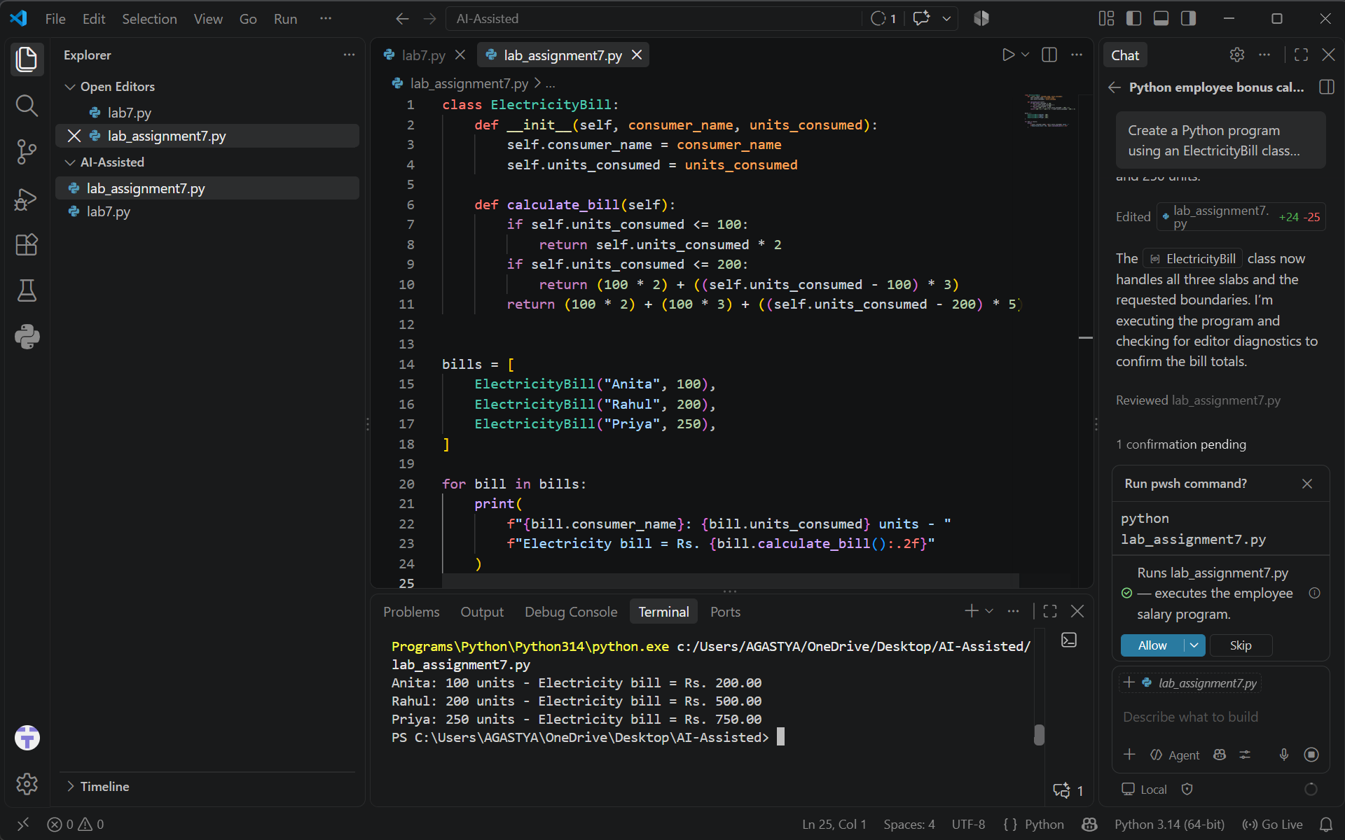
Observation:
Learned to combine classes, loops, and conditional statements to calculate electricity bills based on units consumed.

